Modified Walch
Centered humeral head, minor erosion | 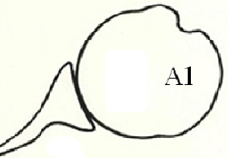
Centered humeral head, major central glenoid erosion.  A line drawn from the anterior to the posterior rim of the native glenoid transects the humeral head. | 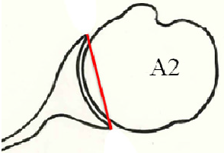
Posterior subluxated head, no bony erosion | 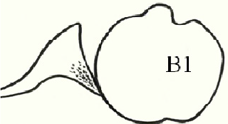
Posterior subluxated head, posterior erosion with biconcavity of the glenoid | 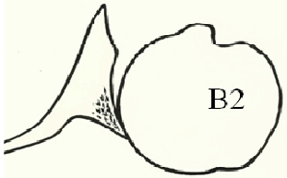
Monoconcave and posteriorly worn,  with at least 15° of retroversion or at least 70% posterior humeral  head subluxation, or both. | 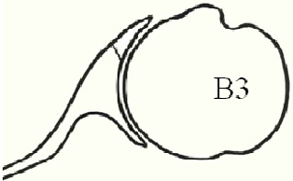
Dysplastic glenoid with at least 25° of retroversion not caused by erosion | 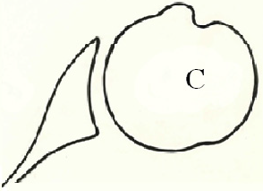
Any level of glenoid anteversion or with humeral head subluxation of  less than 40% (ie, anterior subluxation) | 